

**CSE489: Mobile Application Development**

**Section: 01**

**Mini Project Report**

**School Management System**

**Submitted to:**

**Md Mostofa Kamal Rasel**

**Assistant Professor, Department of Computer Science & Engineering**

**East West University**

**Submitted by:**

|  |  |
| --- | --- |
| **Student ID** | **Student Name** |
| 2018-3-60-117 | Tushar Ahmed |
| 2020-1-60-196 | Md. Abid Sarkar |
| 2020-1-60-079 | Md. Asif Hasan |

**Introduction:**

**School Management system** is a cutting-edge Android software developed to boost productivity and streamline university operations for both students and faculty. It has a variety of functions, such as test schedule management, event development, mark distribution, and the ability to broadcast crucial alerts to individual teachers or students. Its goal is to remove difficulties that are regularly faced in the academic environment.

**Background:**

The **School Management system** app is created in response to a rising demand to streamline university processes and improve the overall learning experience for students and professors. Traditional ways of handling activities, communication, and information have grown increasingly burdensome and time-consuming as colleges have gotten more dynamic and complicated.

Recognizing these obstacles, a committed our team worked to build the University Assistant app. Their objective was to create an innovative solution that would answer the unique demands of the university setting while also bridging the gap between students and professors.

**Motivation:**

**School Management system** is an innovative Android application that acts as a centralized platform for organizing numerous duties and information in a university context. It is intended to increase productivity and streamline university processes for both students and faculty.

The software includes capabilities such as test schedule administration, event planning, mark distribution, and the ability to broadcast crucial alerts to individual teachers or students. These elements encourage efficiency, organization, communication, cooperation, personalization, and accessibility.

**Problem Statements:**

Understanding diverse requirements, integrating with existing systems, designing a user-friendly interface, ensuring scalability and performance, prioritizing security and privacy, and promoting user adoption through training and support were all challenges in developing the University Assistant app. To overcome these obstacles, we needed more time to implement all of the solution.

**Features: 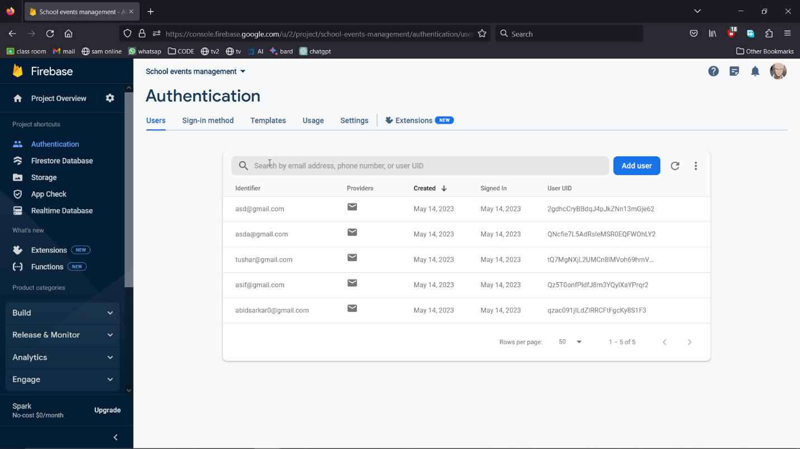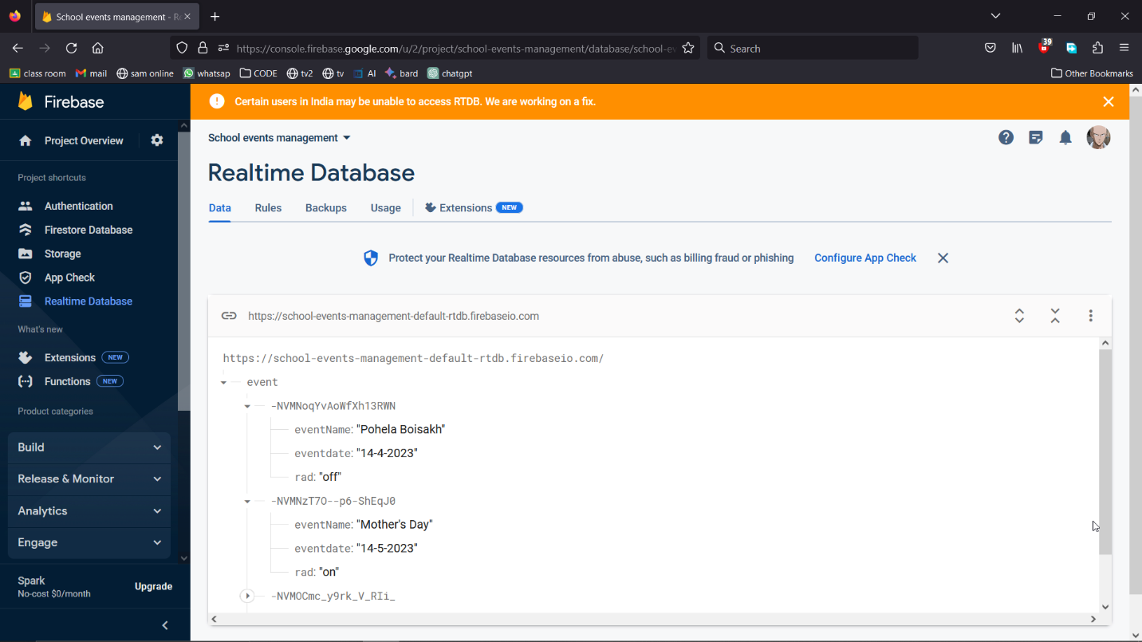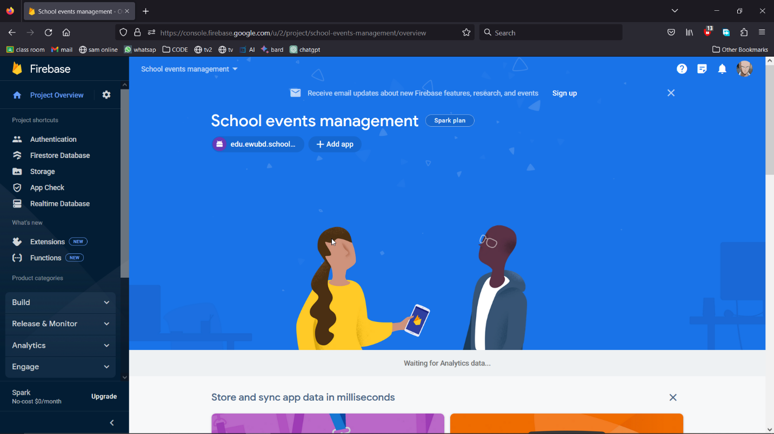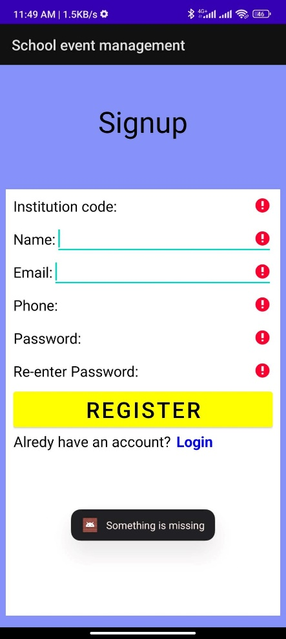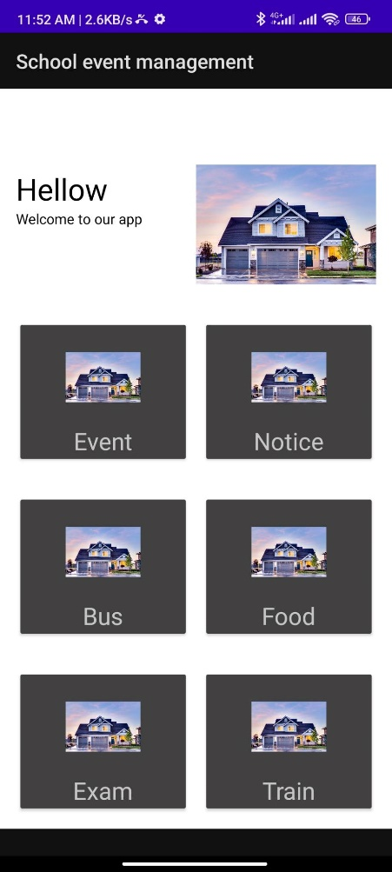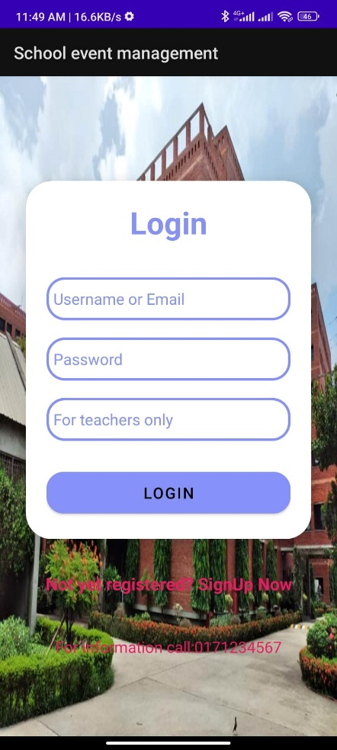\**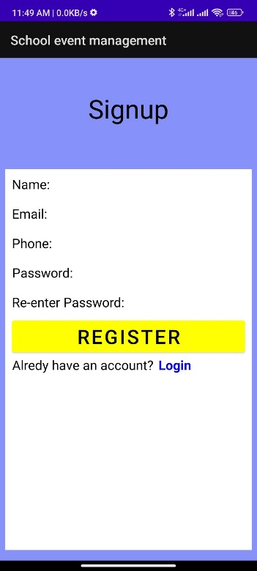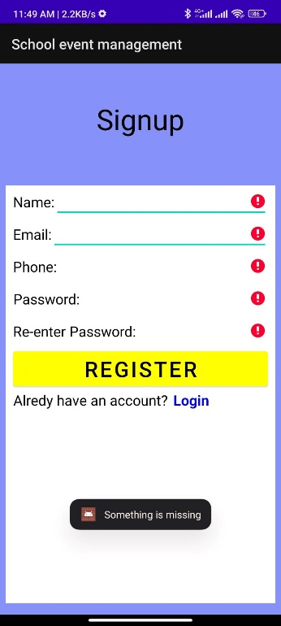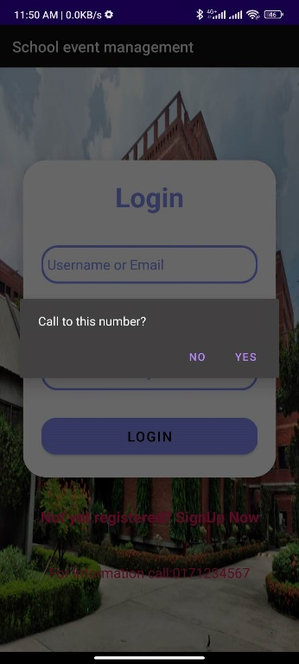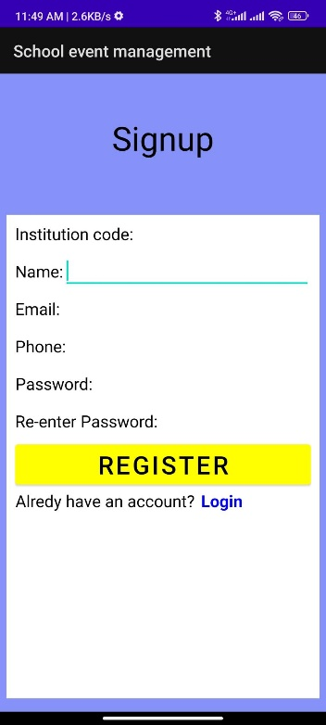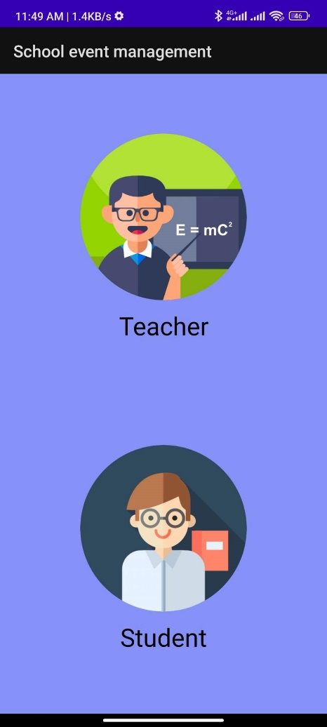

**Here are all features for student and tutor**

**Business Model:**

As our software is developed with some helpful features of education sector, we will go for ***subscription*** based freemium model. We will charge 100 takas per month for post more than 2 in every month for every teacher.

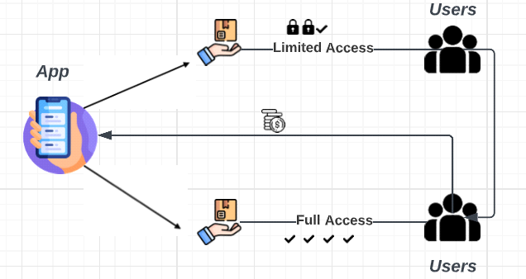

**Figure:** Business Model of Tuition Management

**Conclusion:**

The app is wonderful for tutor and student as it is known to personally selecting all its tutors featured on its online platform. The interested student simply needs to book one and the tutor will come to the student’s place at the planned schedule. This way it keeps the students and parents at ease.